Figure legends
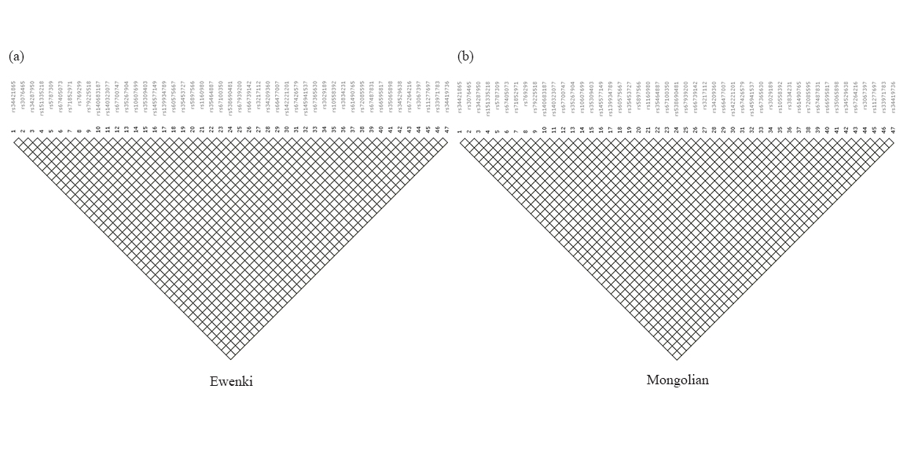
Supplementary Fig. 1. LD tests of pairwise loci in the studied Ewenki and Mongolia ethnic groups.

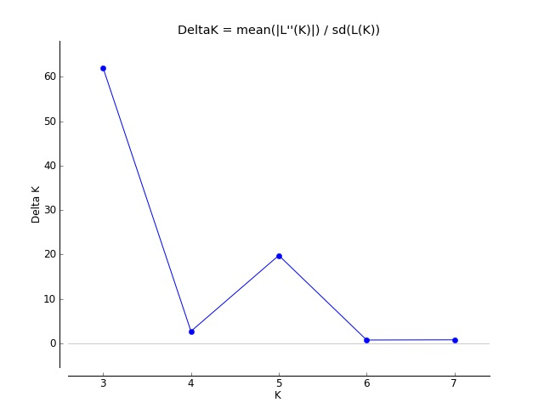
Supplementary Fig. 2. determination of Optimal K with the results of Delta K.

